Mydatahack.com

1. Editing the explanation below the blog title

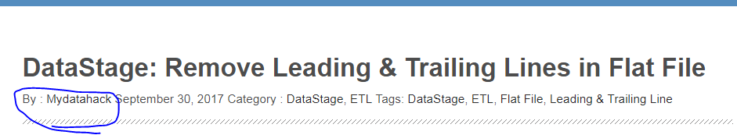

This is controlled in a function in theme-default-setup.php.

Edit the format for date in $imnews_date & removed the first list that says by

